

30th Apr 2022

**PROJECT COMPLETION CERTIFICATE**

This is to certify that Mr Vasa Venkata Aravind Trainee ID 40109552 student of “Gudlavalleru Engineering College, Gudlavalleru” has completed the project entitled “CUSTOMER ANALYSIS WITH DATA SCIENCE” under the guidance of “Sureka Rajeshwari” from 21st Feb 2022 to 30th Apr 2022 at Hyderabad for the academic requirements of his graduation.

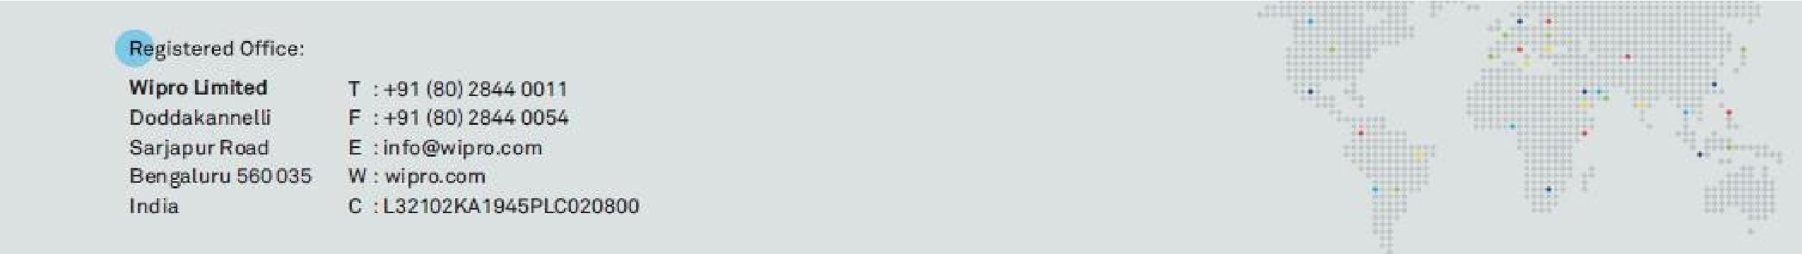

40109552

We have observed that your work was excellent and we appreciate your sincere learning.

You have performed the project with energy and enthusiasm. This letter is issued based on your request.

We wish you all the very best in your career ahead!

